Discourse Chart Helper
This application helps you prepare discourse analysis charts to study discourse features of a vernacular language text. Here is an image of the program:
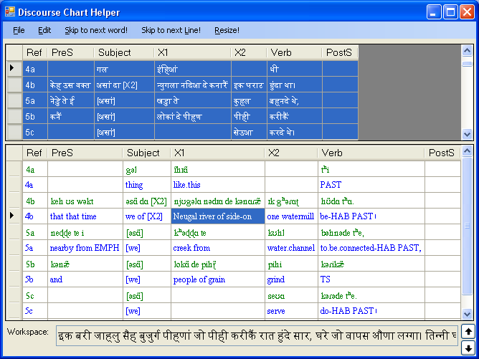
Figure 1: Discourse Chart Helper

Usage notes

Loading a text
You can load a text for charting in one of two ways:

Open a text file (e.g. an SFM document) with the File, Open command. The lines of the text will be shown—one at a time—in the Workspace box at the bottom of the program window. You can use the Skip to next line! menu to skip non-text lines.

Paste text directly into the Workspace window, by copying (say, a paragraph worth of) text to the clipboard from some program (e.g. Ctrl+C in MS Word) and then right-clicking on the Workspace window.

Placing words in the chart cells
Once you have some text in the Workspace box, you can do any of the following:
- Click on a cell in the chart in the upper portion of the program window to have the first/next word in the Workspace box moved to the clicked cell.
- Right-click on the chart in order to undo the last word moved. This moves the word back to the Workspace box. This is useful, for example, if you click on the wrong cell and want to re-do the word placement.
- Click on the Workspace box itself to cause the next word to be deleted. This is useful, for example, to skip past non-text words (e.g. SFM markers). You can also use the Skip to next word! menu item to delete words in the Workspace box.

Column order
You can drag the column headers in the upper chart to re-order them. When you do, the lower chart (if visible) will automatically adjust to match. You can reposition any column except the reference column.

Reference numbers
- When you click in a chart row for the first time, the row will automatically be given the reference number that is next in order (e.g. if the previous row is 1a, then the next row will be made 1b, for: sentence 1, clause b)
- If you want to make the reference skip to the next sentence number (i.e. to make 1b into 2a), then click once on the reference (Ref) column cell you want to change.
- If you right-click on the reference cell, it will reset to its initial value (e.g. 1b).

Transliteration
If you want to show a transliteration of the vernacular text in the chart, you can click the File, Transliteration, Show menu item. If you have SILConverters installed (v2.2 and greater), the latin transliteration of the vernacular words will be displayed in a parallel chart at the bottom of the program window (see Figure 1).
By default, the program uses the Any-Latin ICU transliterator. You can change the transliterator used by clicking the File, Transliteration, Choose SILConverter menu to select a different transliterating converter.
Click on the row header in the (upper) vernacular chart to select the rows of the text that you want to see transliterations for. The lower chart will always show the transliteration of the rows selected in the upper chart.

Glossing
If you use AdaptIt to gloss the same text that you are charting, you can show the word glosses of the charted text in a chart in the lower portion of the application window by following these steps:

Add an AdaptIt knowledge base lookup converter. Following these steps:

Click the File menu, Glossing, Choose SIL Converter item.

In the Select Converter dialog box, click the Add New button.

Select the AdaptIt Knowledge Base Converter item and click the Create button.

On the Setup tab of the resulting dialog box, choose the AdaptIt knowledge base project that corresponds to the glossing KB for the vernacular text in the chart.

Click OK (or Apply) and then click Yes to add the gloss lookup converter permanently to the repository.

Return to the Discourse Chart Helper program by clicking OK as needed.

Click on the row header in the (upper) vernacular chart to select the rows of the text that you want to see glosses for. The lower chart will always show the glosses (and transliteration) of the rows selected in the upper chart.

Adding words to the AdaptIt glossing knowledge base from Discourse Chart Helper
If a particular vernacular word is in the AdaptIt glossing knowledge base, then its gloss will be shown in the lower chart (see Figure 1). If you see the vernacular word itself in the gloss chart, it means that the word wasn't in the AdaptIt knowledge base. You can add words to the AdaptIt knowledge base from this application by right-clicking on the cell in the lower chart. The Add Knowledge Base Entry dialog box will appear in which you can type the correct Gloss for the given Vernacular word.
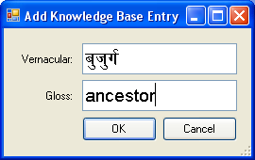
Figure 2: Add Knowledge Base dialog box

Click "OK" to save the word in the knowledge base and update the glossing chart.

Ambiguities
If a particular vernacular word is ambiguous, then all the possible glosses will be shown in the chart cell separated by the % symbol. The number of possible ambiguities will be displayed as the 2nd character (e.g. the 5 in the string: %5%she%they%those%he%that%). If you click on a cell that contains ambiguous words, then the "Pick Ambiguity" dialog box will appear:
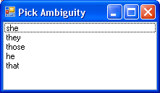
Figure 3: Pick Ambiguity dialog box

From this dialog box, you can choose the correct gloss for the ambiguous vernacular word.
Once the gloss has been successfully read from the knowledge base (and picked from the ambiguity dialog box, if needed), it will be saved in the chart file along with the vernacular text (e.g. when you click the File, Save Chart menu item). If you change the glosses in the AdaptIt knowledge base, those changes will not automatically be updated in this charting tool. To cause the glosses to be re-queried from the knowledge base, click on the row header of the row that you want to re-query (in the lower chart).

Copying example sentences
If you select one or more rows in the upper chart (i.e. by clicking on their row headers), you can copy them to the clipboard by typing Ctrl+C. The rows of data can then be pasted in another application (e.g. in MS Word by typing Ctrl+V). The vernacular text will be copied (along with the associated transliterations and glossing lines) in an HTML table format. See example below.

Free translation
If you want to include a free translation for one or more rows in the chart (to be included in any copied data), right-click on the row header of the last row for which the free translation applies. A dialog box will be displayed in which you can enter the free translation.
The free translation won’t be visible in the Discourse Chart Helper, but will be included in any data copied to another application. Here is an example of some copied rows for which a free translation was added to the row header on rows 4b and 5c:
Figure 4: Example copied records
Ref | PreS | Subject | X1 | X2 | Verb | PostS
4a |  | गल  gala  thing | इंहिआं  inhi'āṁ  like.this |  | थी  thī  PAST
4b | केह उस वक्‍त  kēha usa vak‍ta  that that time | असां दा [X2]  asāṁ dā [X2]  we of [X2] | न्‍युगला नदिआ दे कनारैं  n‍yugalā nadi'ā dē kanāraiṁ  Neugal river of side-on | इक घराट  ika gharāṭa  one watermill | हुंदा था।  hundā thā.  be-HAB PAST
The thing was that at that time we used to have a watermill on the edge of the Neugal river.
5a | नेड्डे ते ई  nēḍḍē tē ī  nearby from EMPH | [असां]  [asāṁ]  [we] | खड्डा ते  khaḍḍā tē  creek from | कुह्‌ल  kuh‌la  water.channel | बह्‌नदे थे,  bah‌nadē thē,  to.be.connected-HAB PAST,
5b | कनैं  kanaiṁ  and | [असां]  [asāṁ]  [we] | लोकां दे पीह्‌ण  lōkāṁ dē pīh‌ṇa  people of grain | पीही  pīhī  grind | करीकैं  karīkaiṁ  TS
5c |  | [असां]  [asāṁ]  [we] |  | सेउआ  sē'u'ā  serve | करदे थे।  karadē thē.  do-HAB PAST।
We connected a water channel from the nearby creek and used to serve by grinding peoples' grain.

